Name – Vaibhav Khandekar

Enroll – 230340325073

Set No – 1

**SQL**

1. Create a orders tables and having 4 constraints in the table(3 Marks)

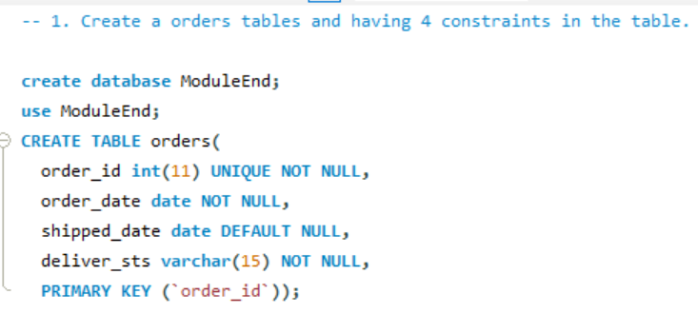



1. Insert minimum three records in the table(2 Marks)

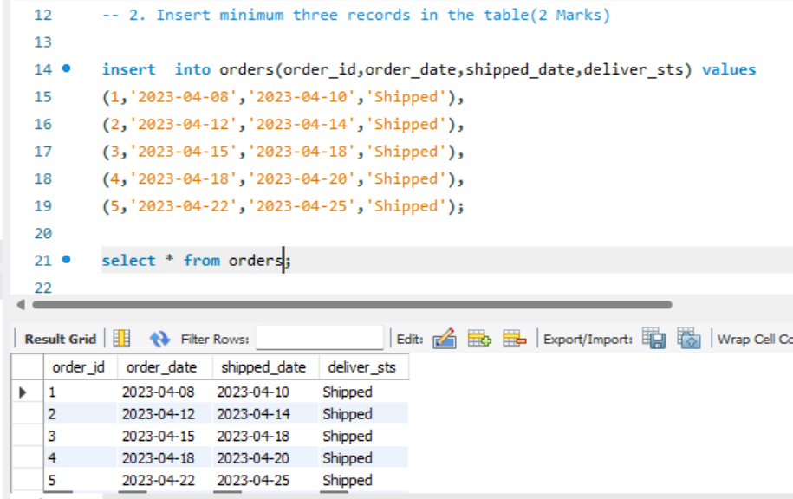



1. 3. Write an Query to find name of employee whose name contains ‘ma’ at any position.

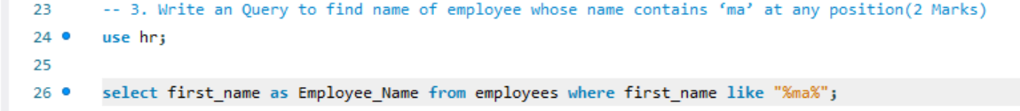

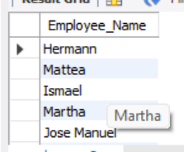



1. 4. Displays number of employees work in each department.



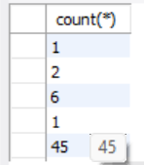



1. Write a query that returns all employees who have a salary greater than the average salary of their department.

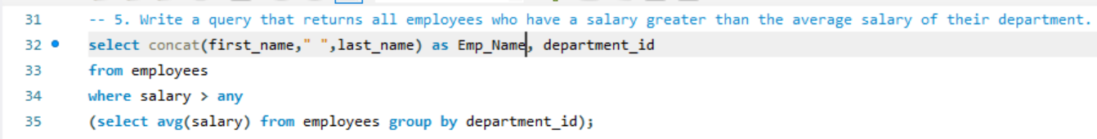

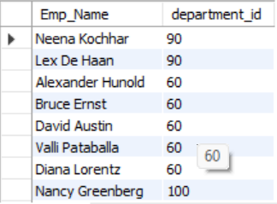



1. Write a query to select all employees and their corresponding department names, but only display those employees who have a manager.

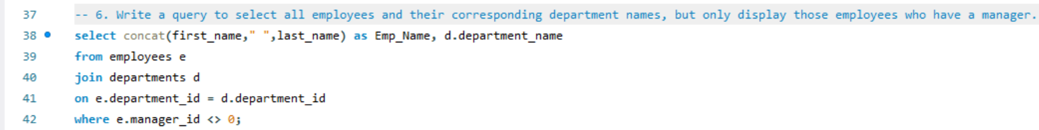

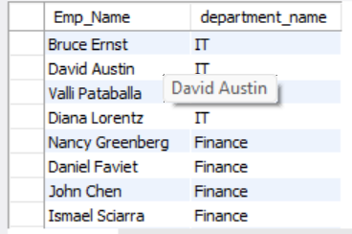



1. Write a stored procedure that updates the salary of all employees in a given department by a specified percentage.

The procedure should take input parameters for the department ID and the percentage increase in salary.

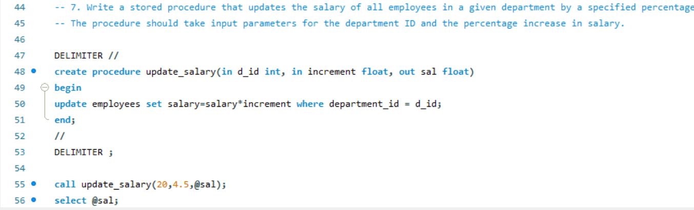



1. Write a stored function that takes an employee ID as an input parameter and returns the number of months the employee has been with the company.

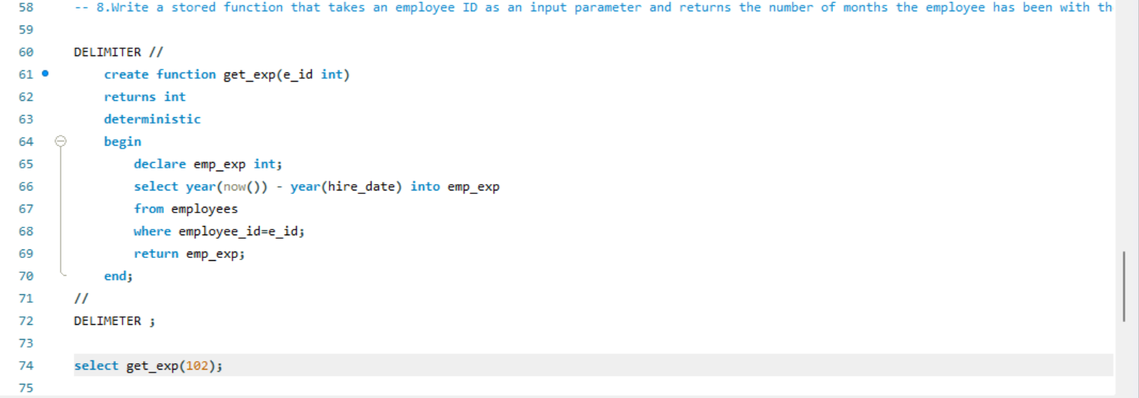



9. Write a trigger to be used to automatically update the Salary history table when any employees salary is updated?

**Mongo DB**

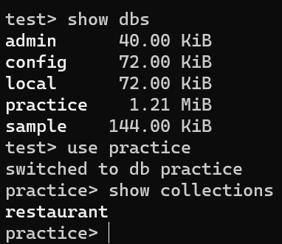

1. To retrieve all documents in the restaurant collection where the name field starts with the letter P.

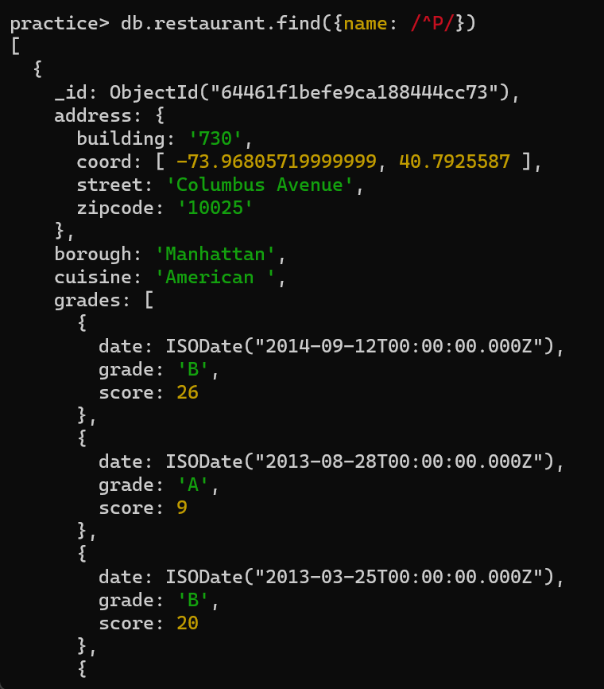

1. To retrieve all documents in the restaurant collection where the cuisine field is equal to Bakery or Chinese.

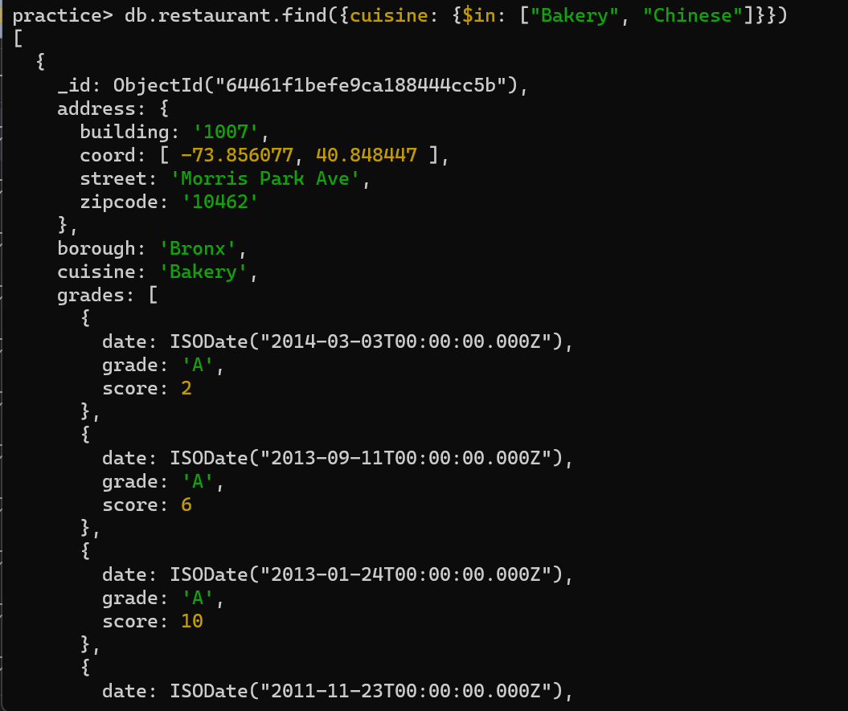

1. To retrieve all documents in the restaurant collection where the grades.score field is greater than or equal to 20.

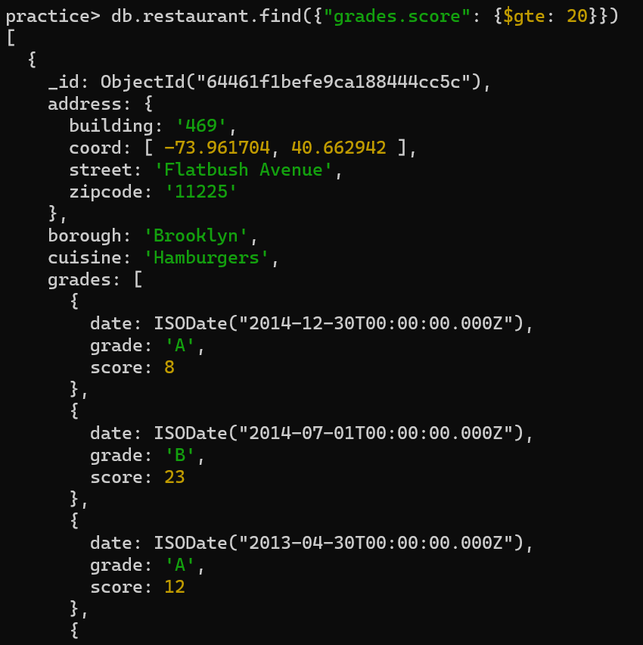

1. To retrieve all documents in the restaurant collection sorted by the name field in ascending order.

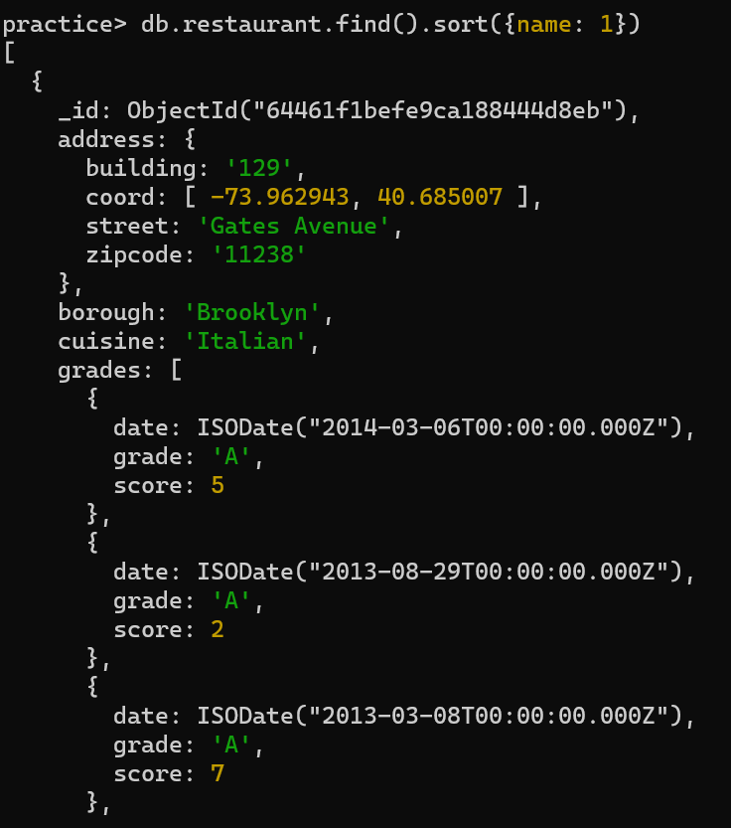

1. To retrieve all documents in the restaurant collection where the grades array contains at least one element where the grade field is equal to A.

